**3-TIER ARCHITECTURE APPLICATION**

**Date:02/04/2024 Name: Siva**

**SERVICES: VPC, EC2, ALB, RDS,R53 (PHP-Sample Application)**

**FRONTEND: 1 SERVER**

**BACKEND: 2 SERVER**

**DB: 1 SERVER**

**Output([www.avsivaranjan.live](http://www.avsivaranjan.live))**

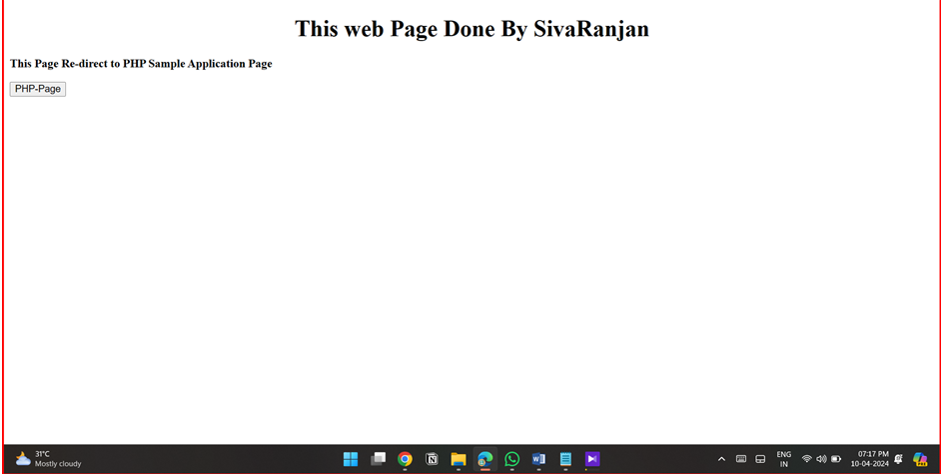

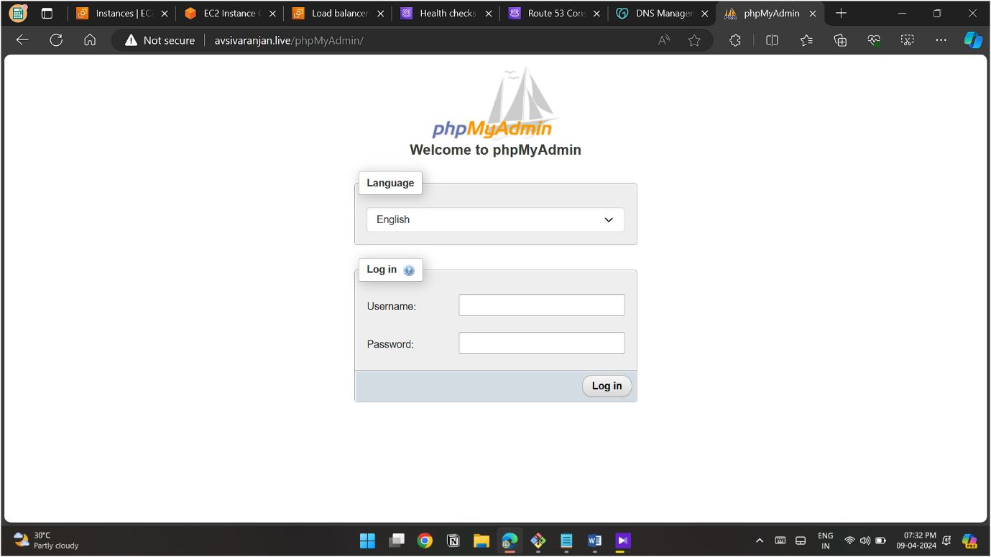

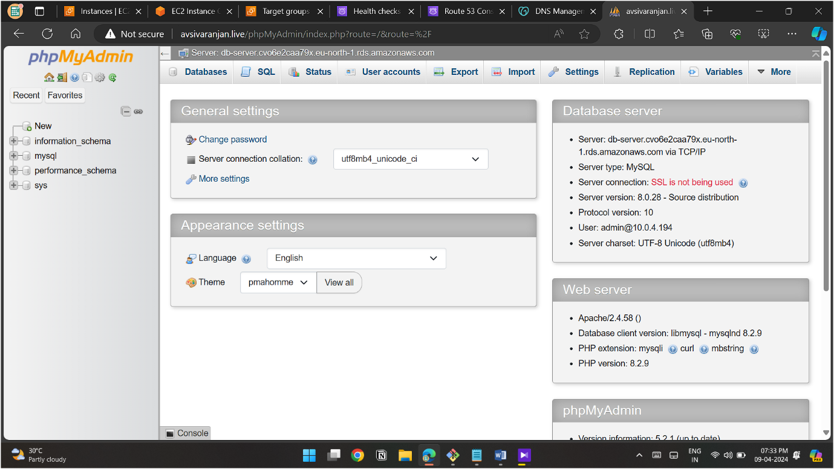

**MODEL**

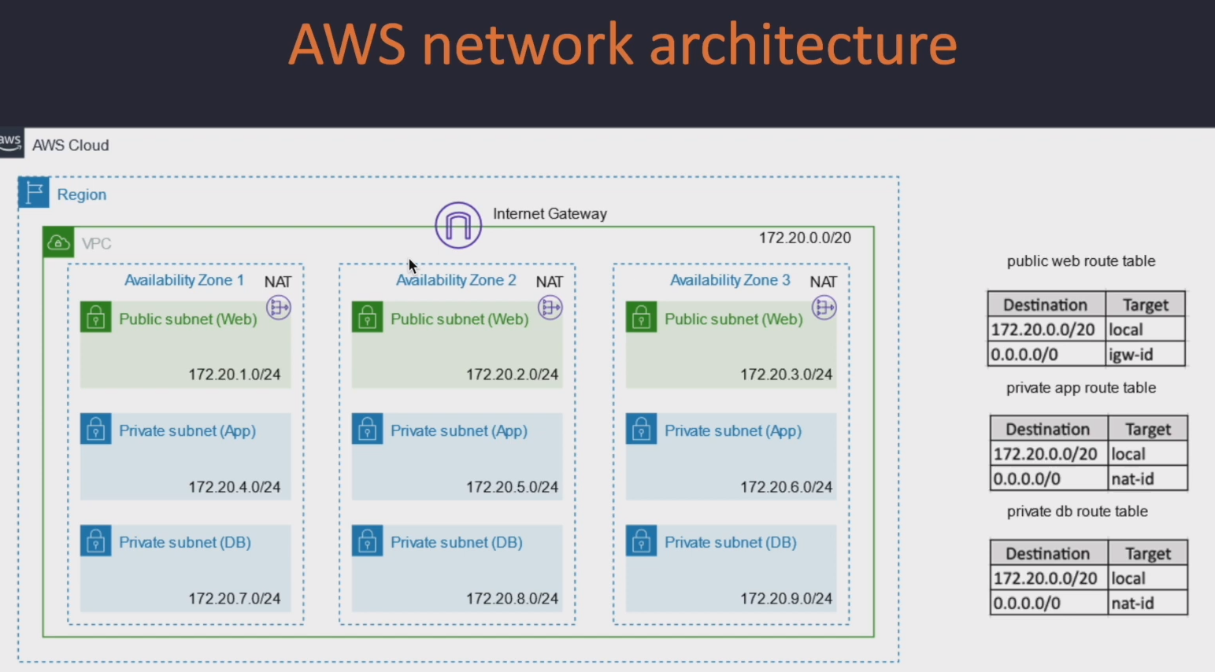

**ALB-MODEL**

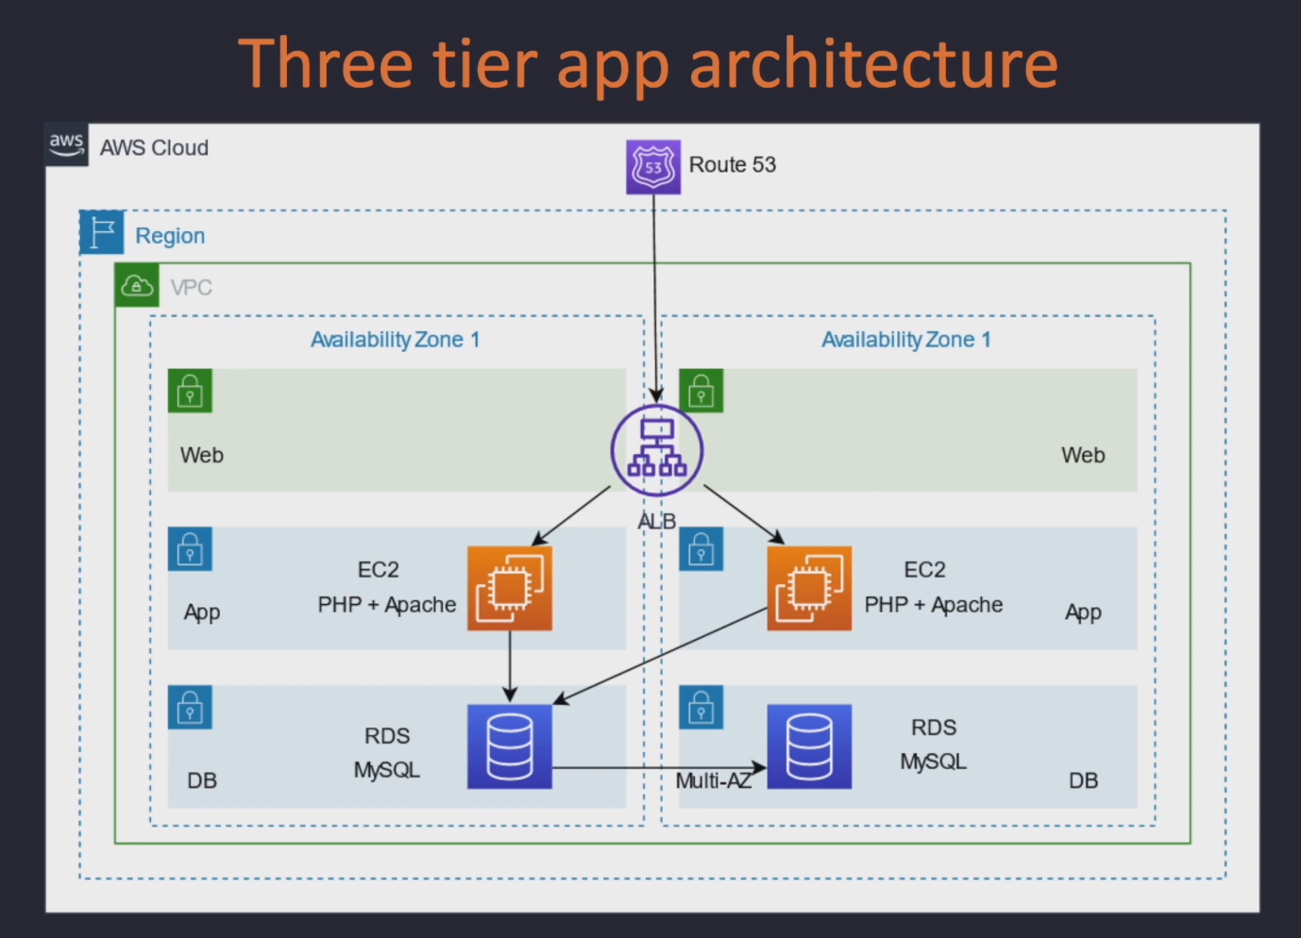

**VPC**

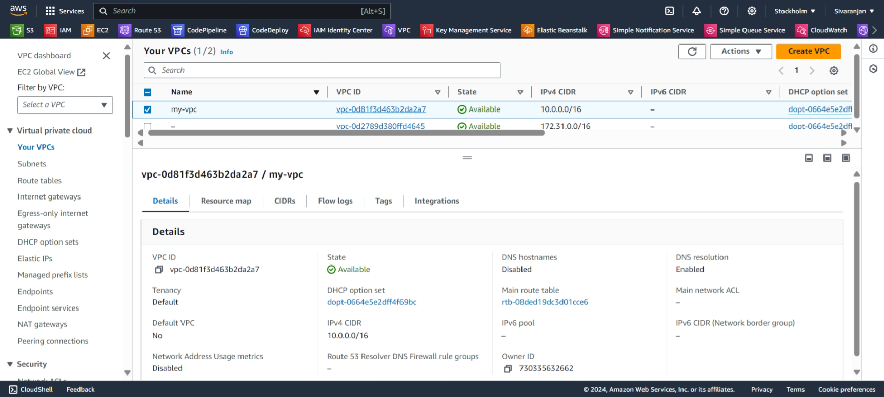

**SUBNETS**

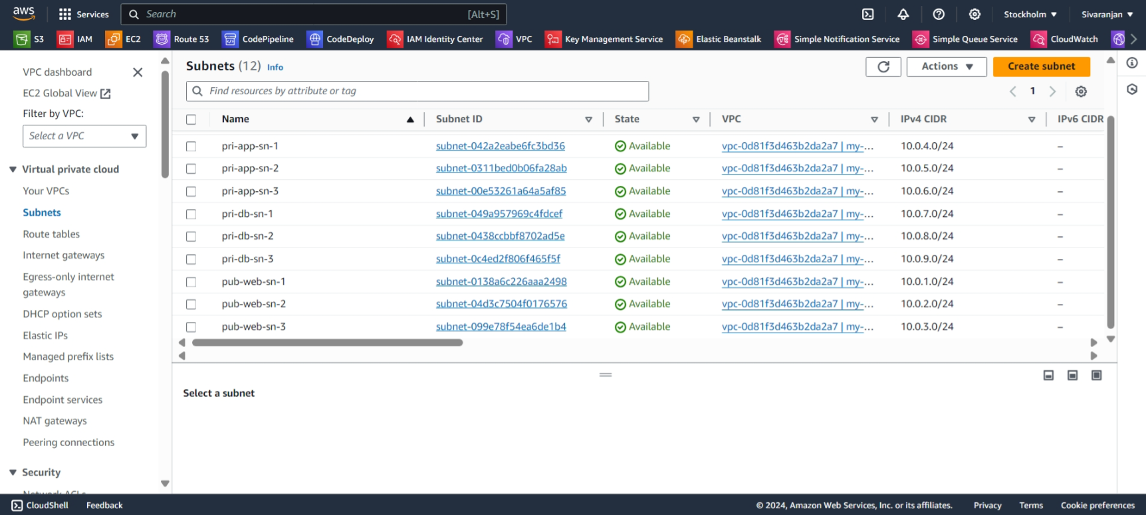

**Pri-app-ec2-sg -> Inbound from SSH(Pub-web-ec2-sg)+HTTP(ALB-SG)**

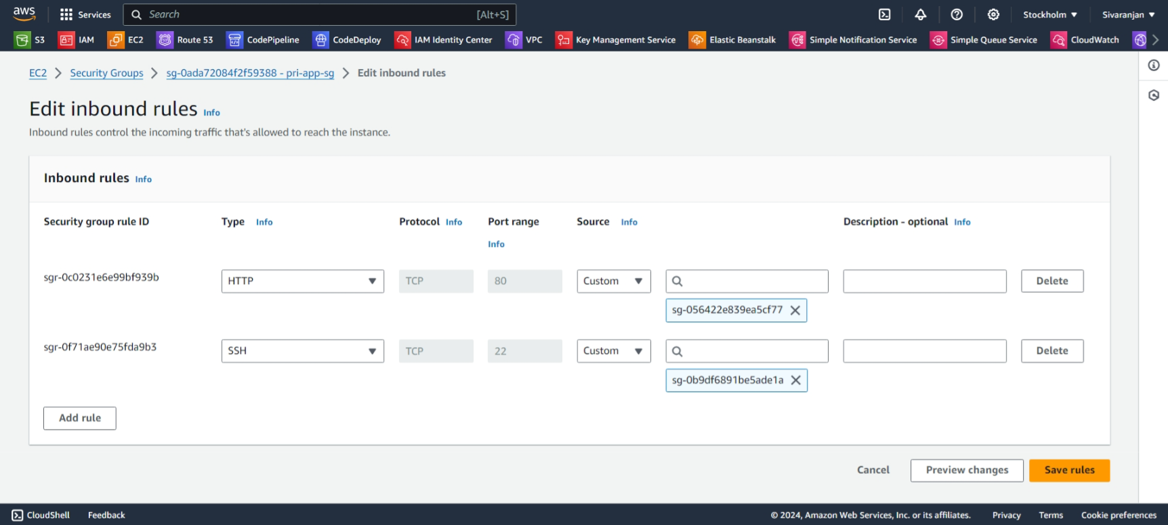

**ROUTE-TABLE**

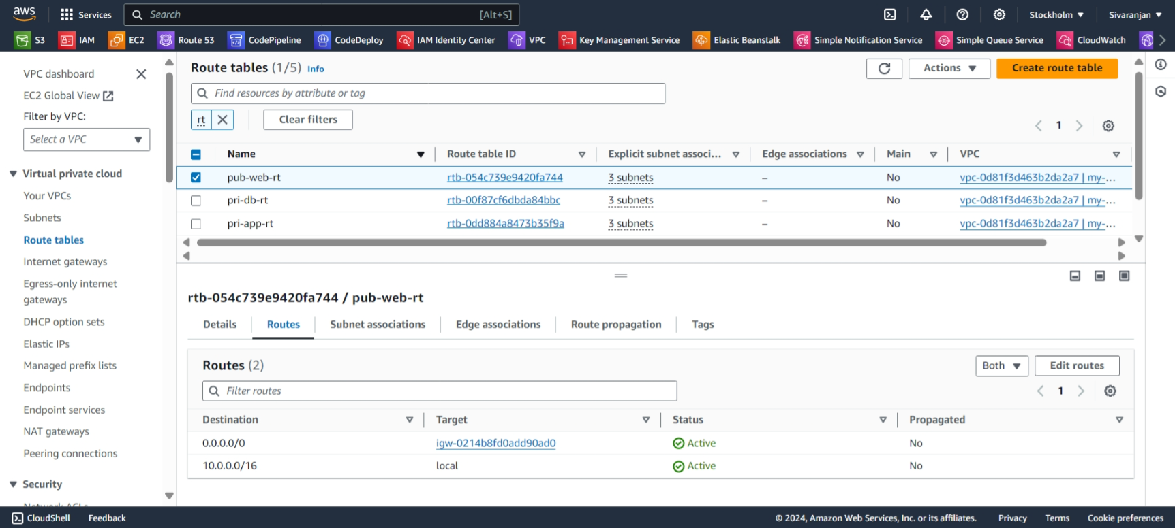

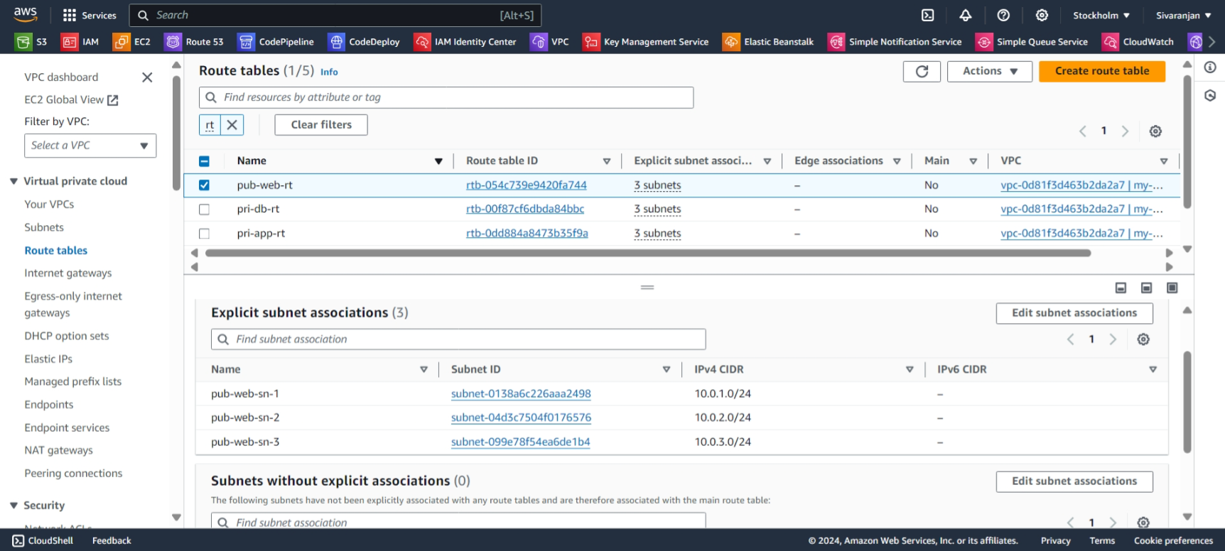

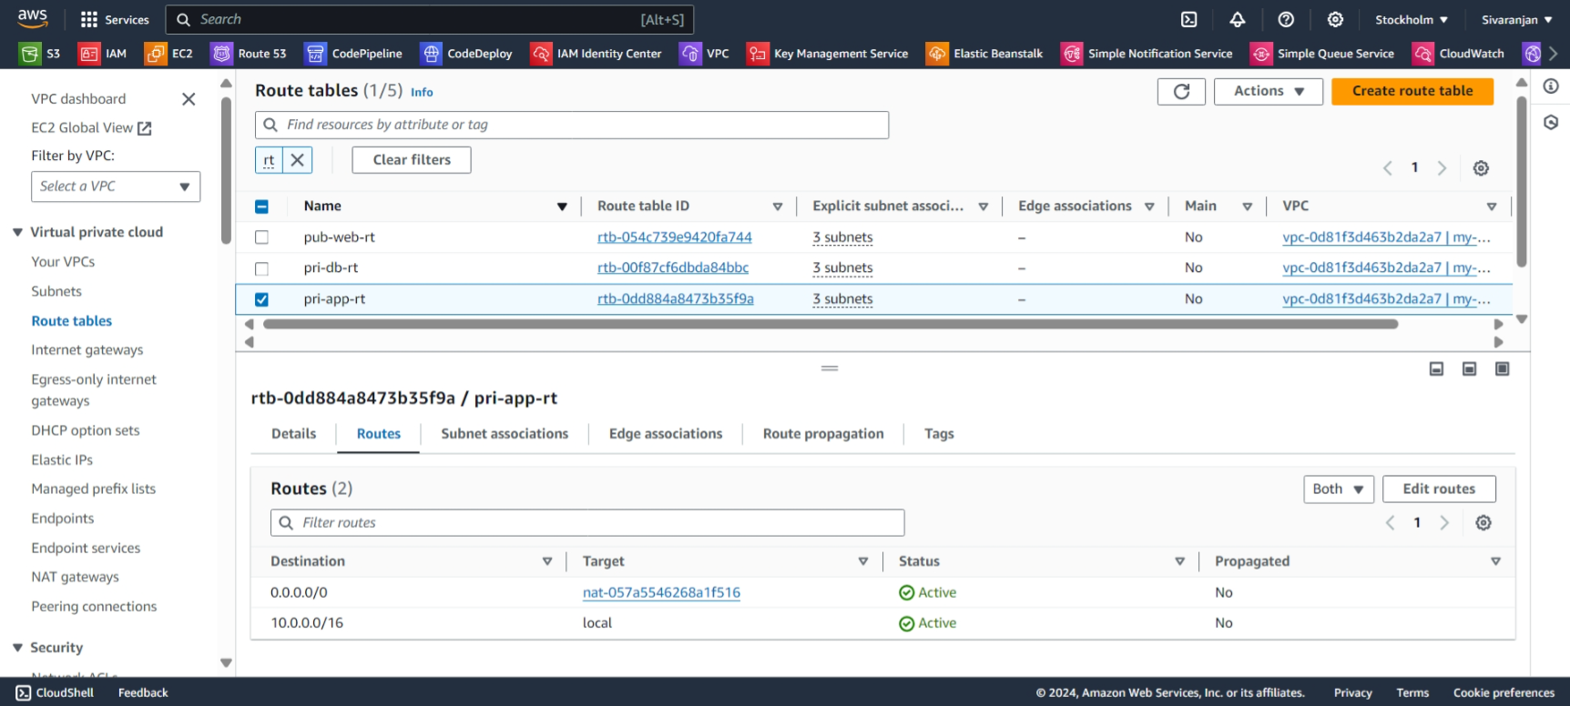

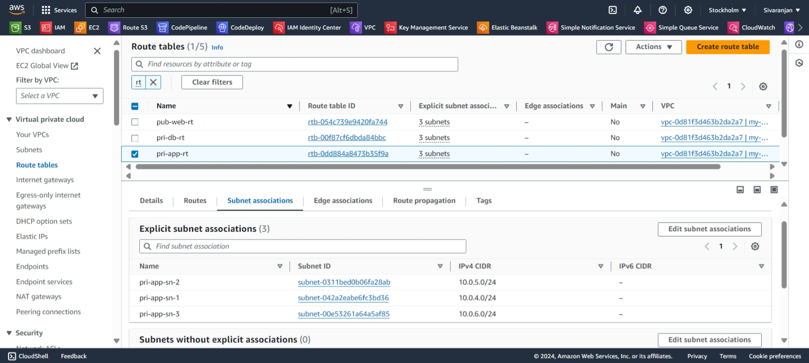

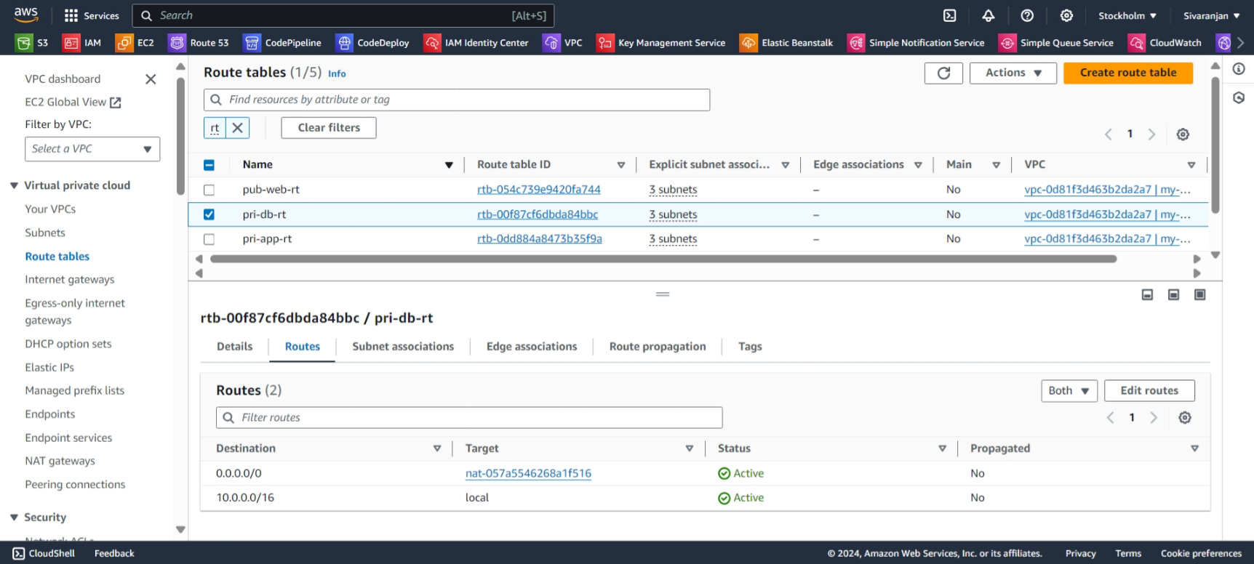

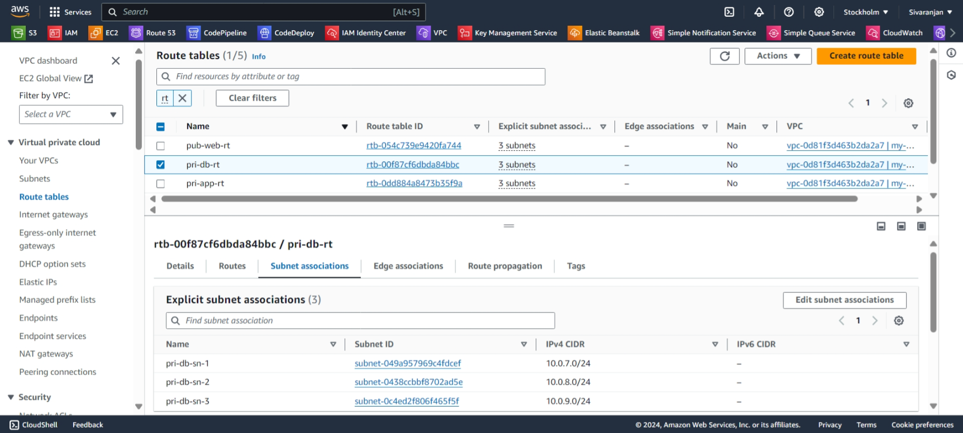

**ALB**

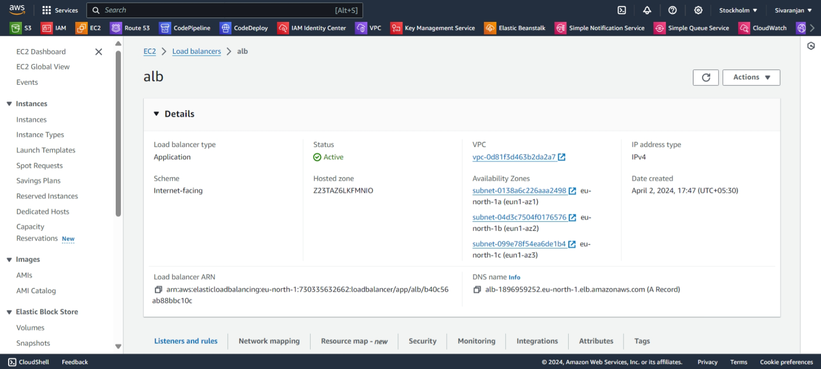

**ALB-MAPPING**

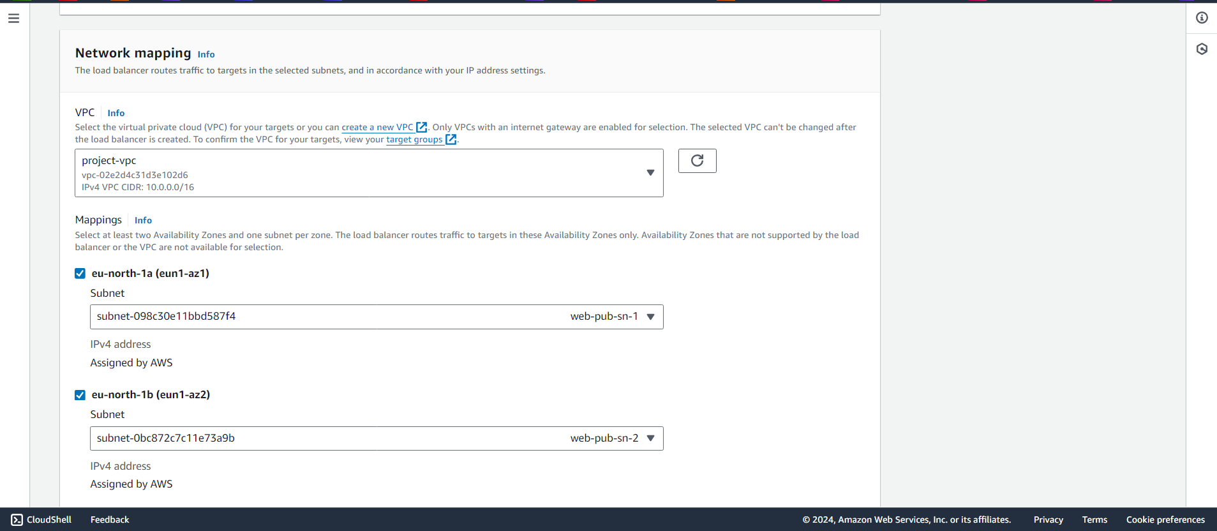

**ALB-SG**

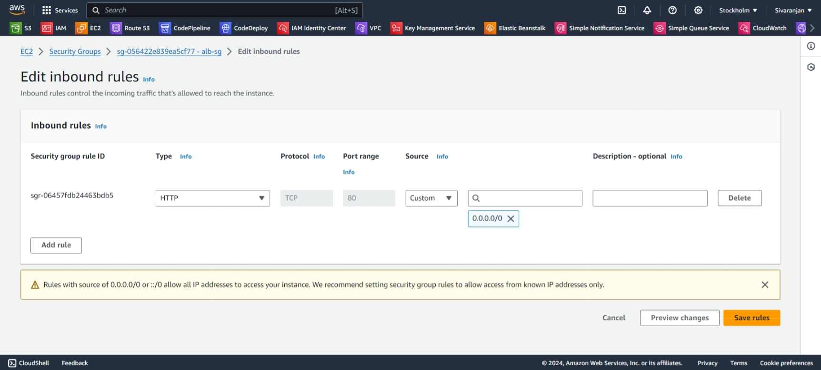

**ALB-TG**

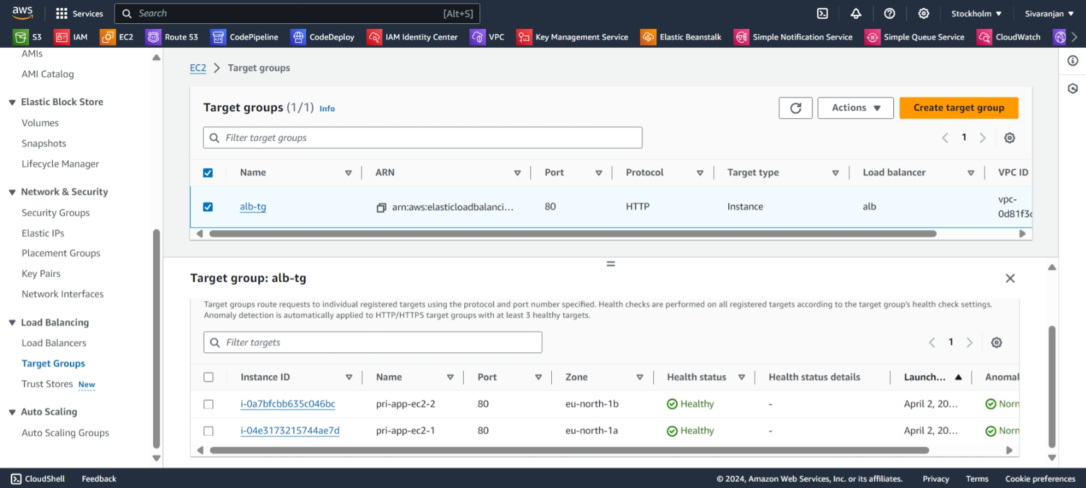

**ALB-Health TIMEOUT**

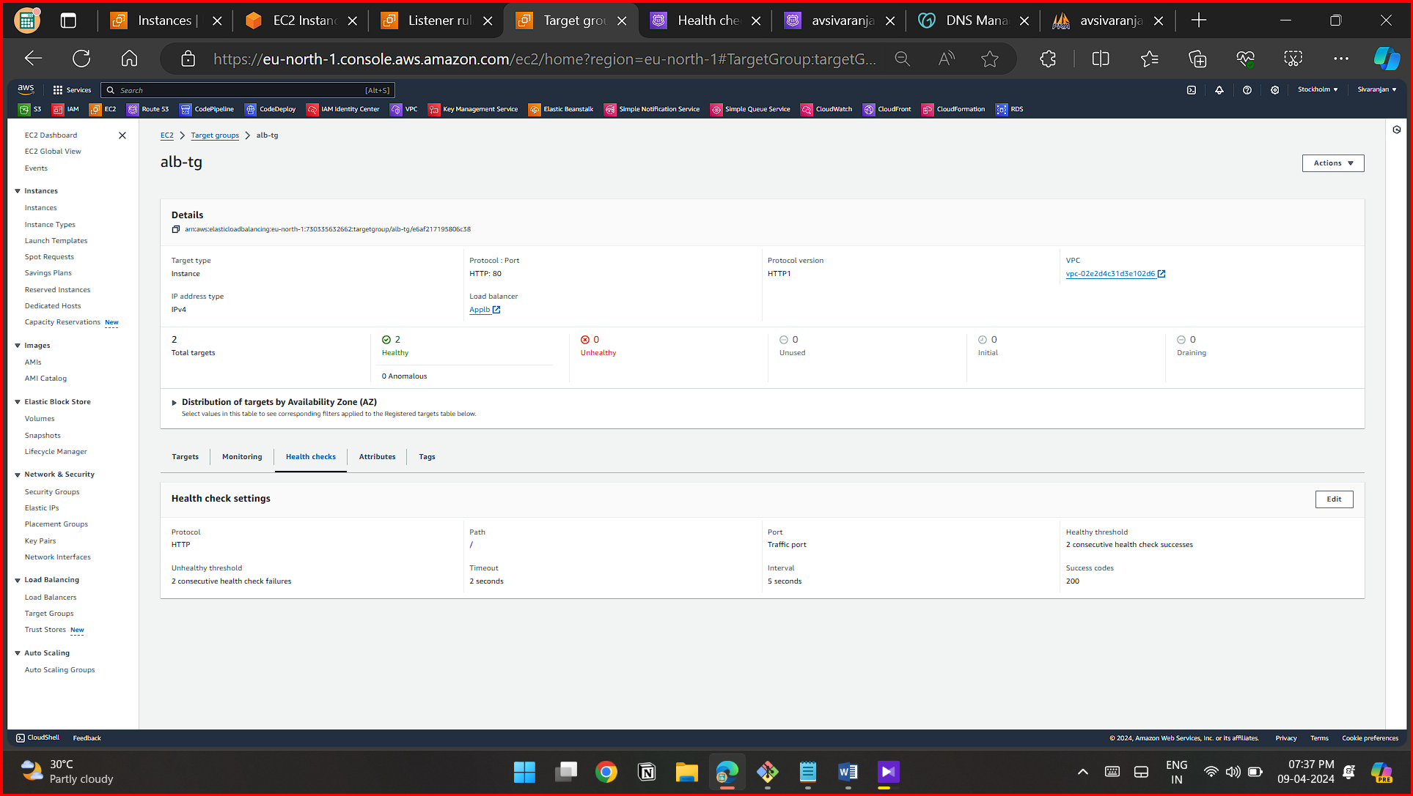



**ALB-Attribute Stickyness**

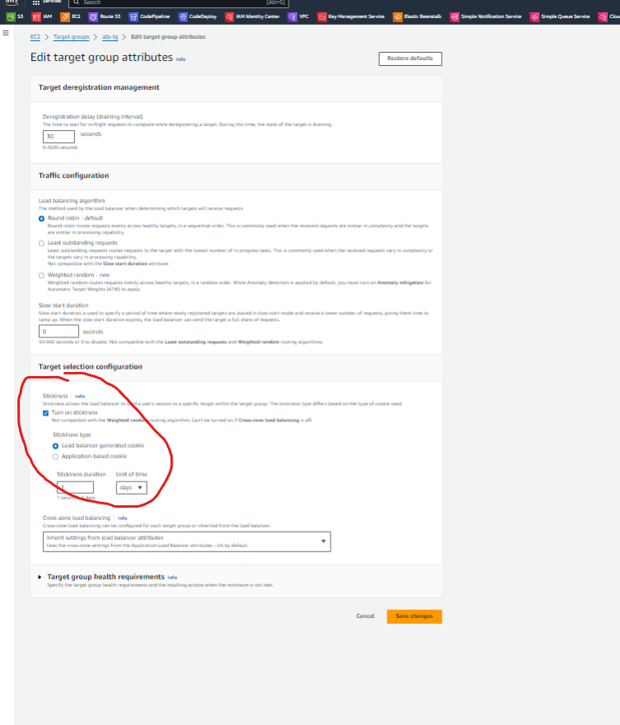

**RDS-SN-GROUP**

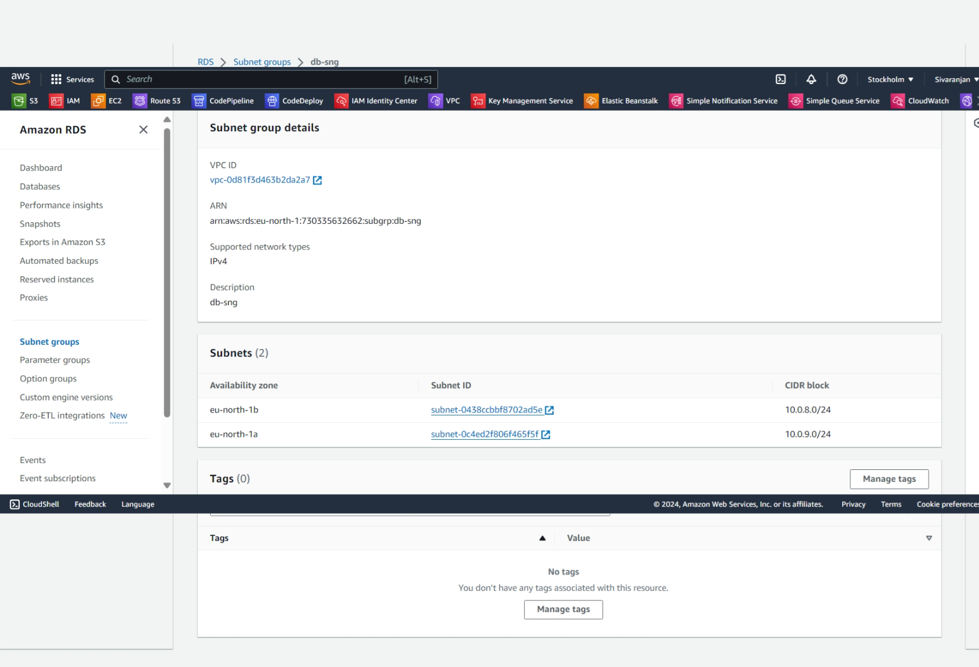

**RDS SG -> Add pri-app-ec2-sg with Port 3306**

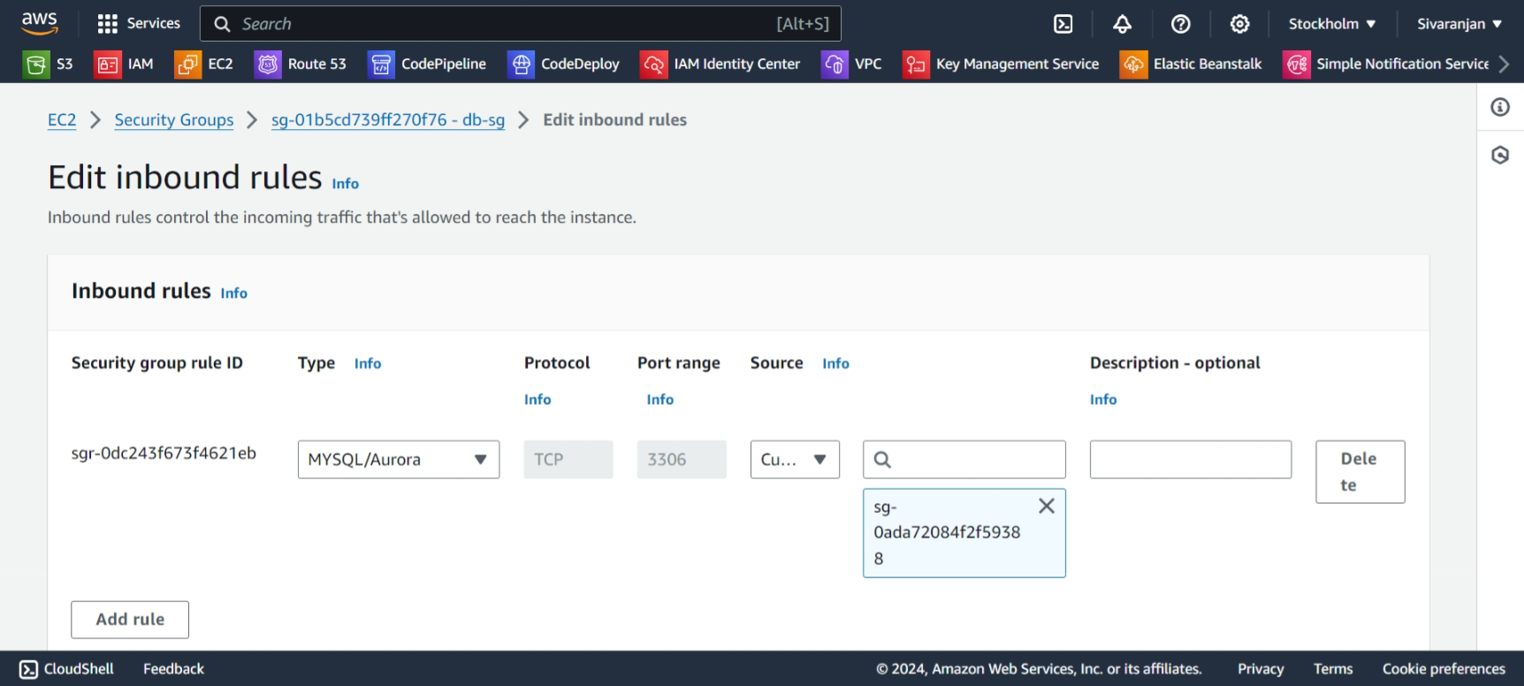

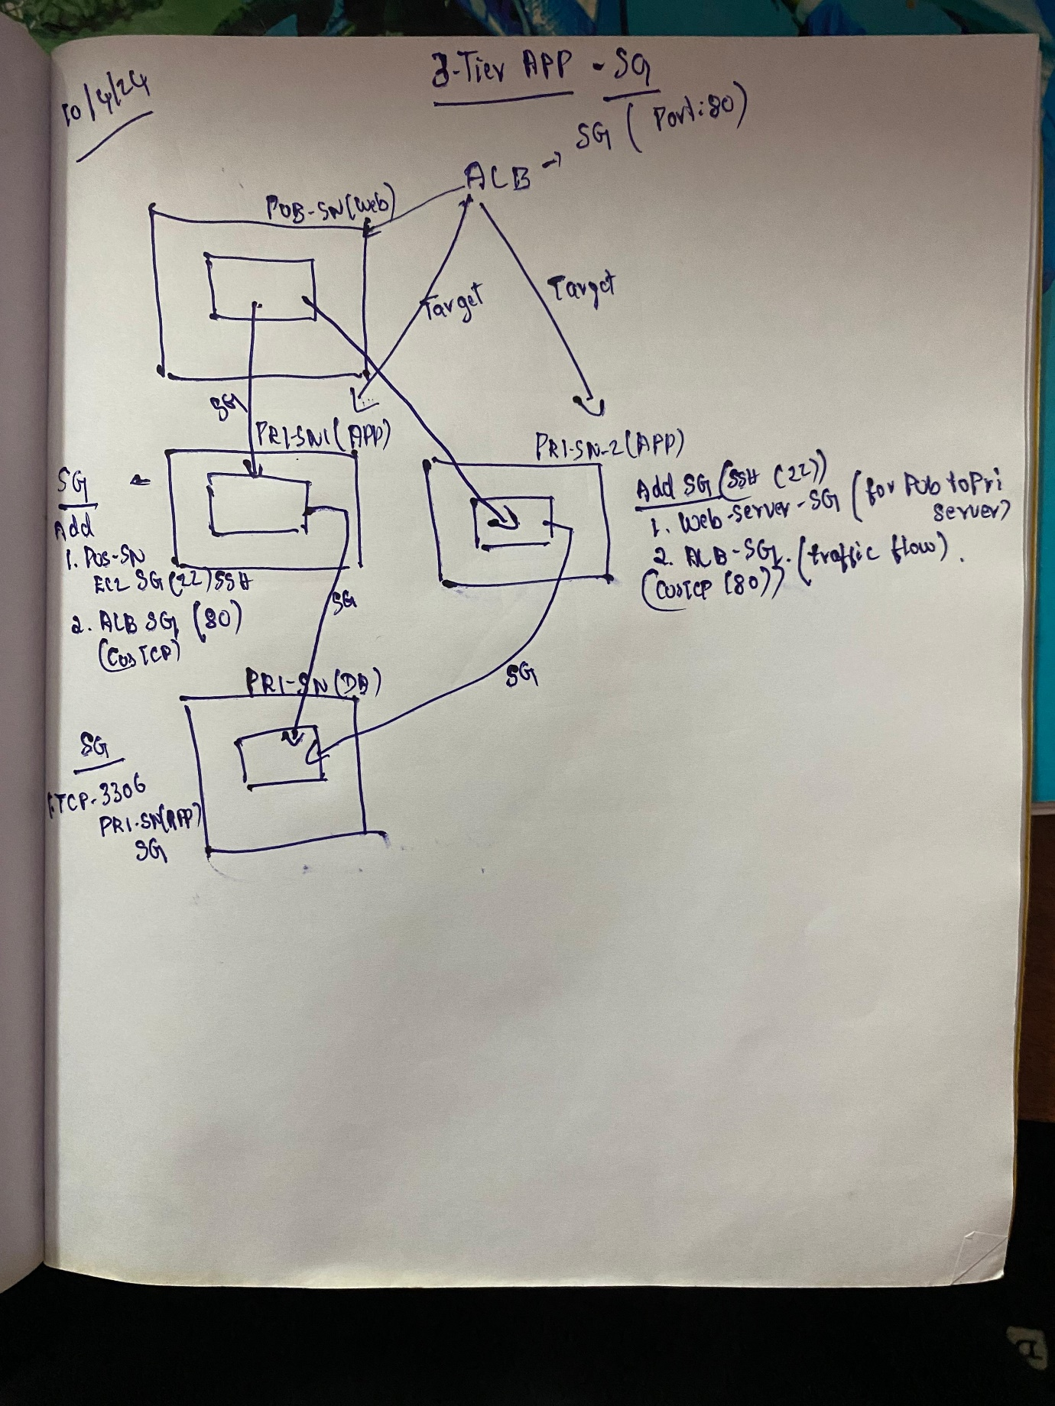

**RDS**

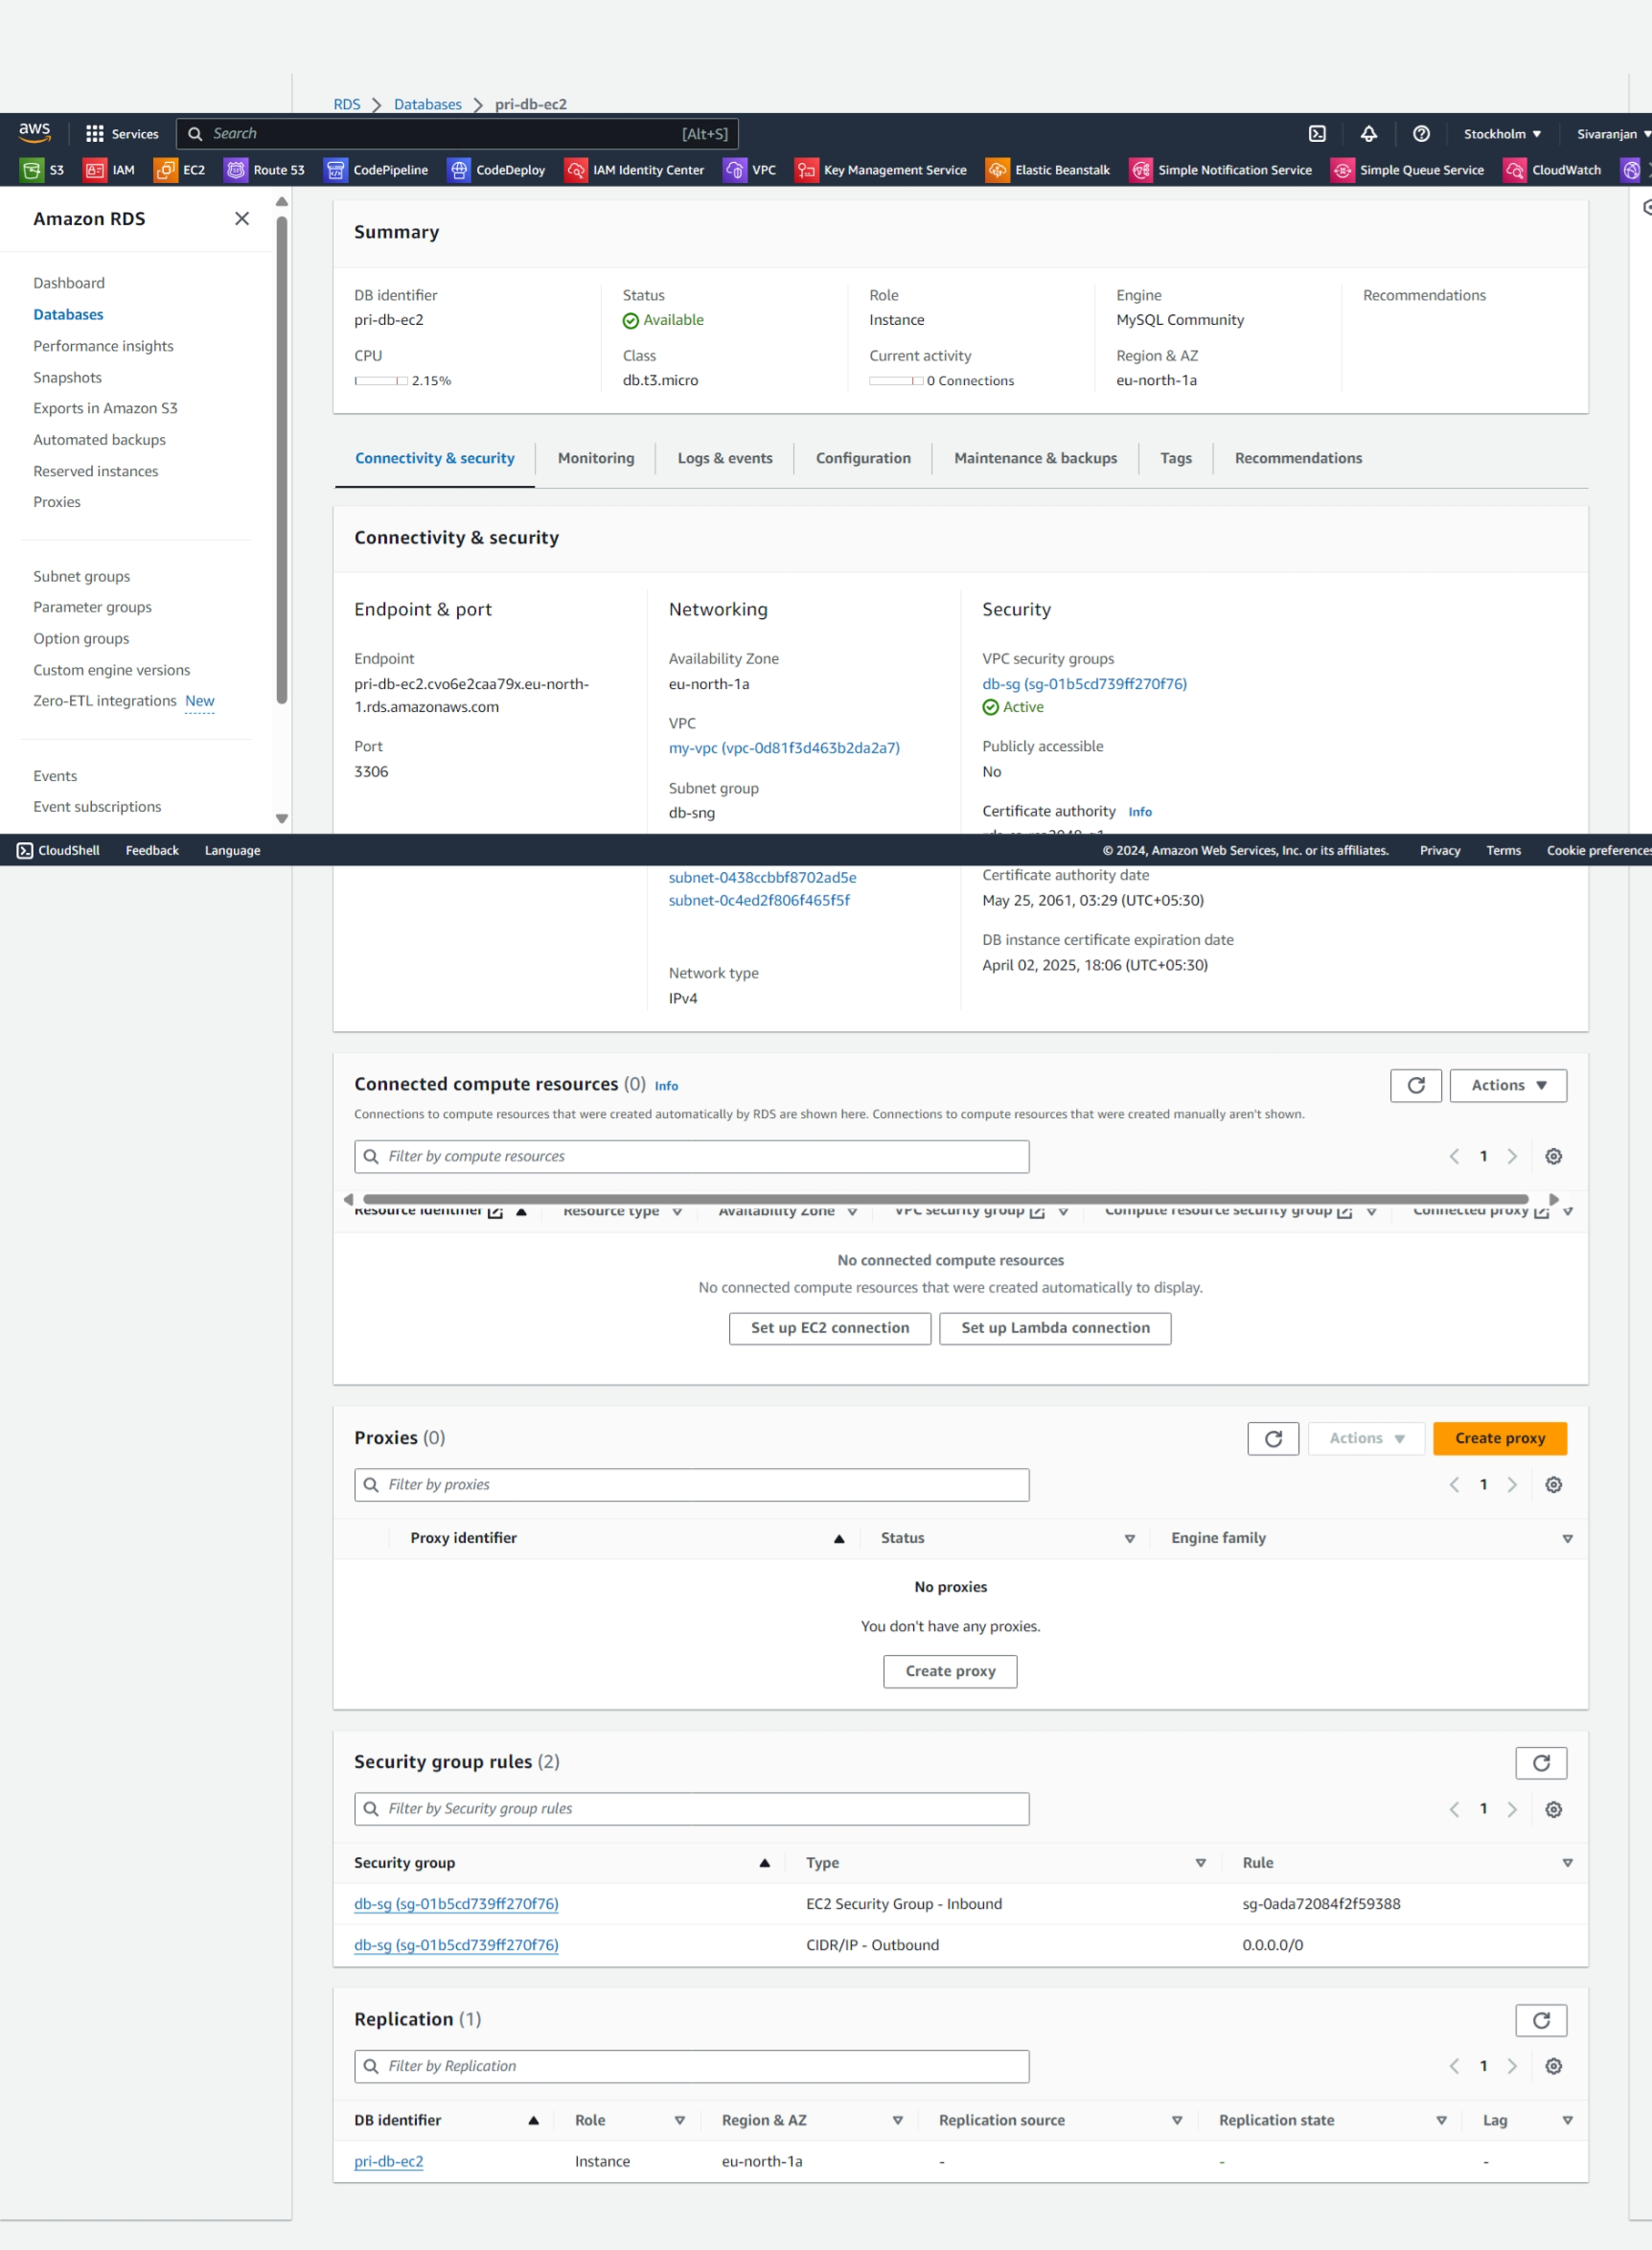

**RDS-SG**

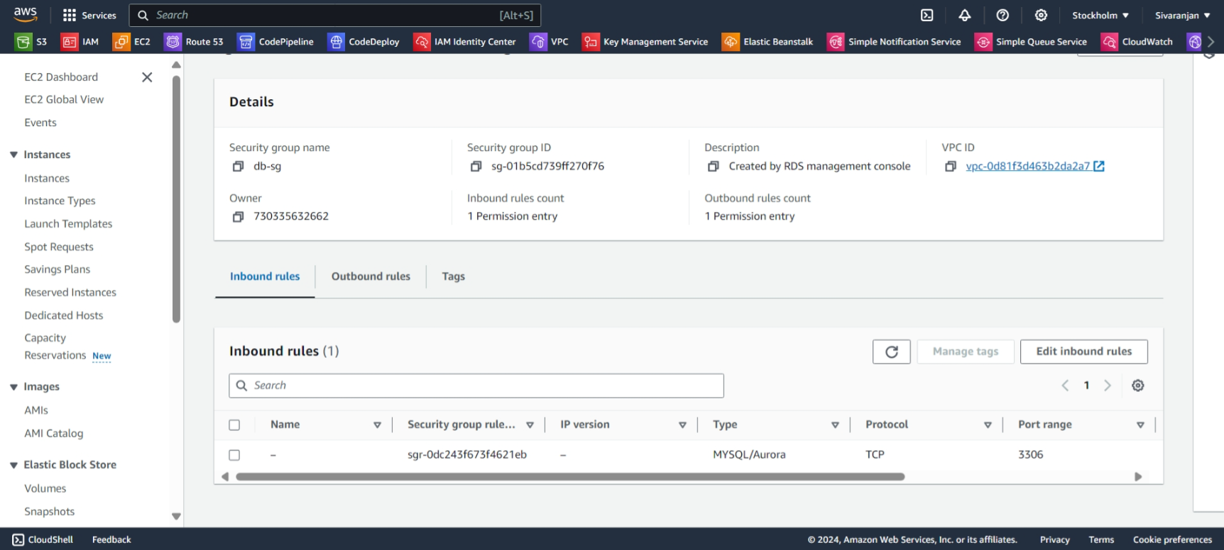

**OUTPUT**

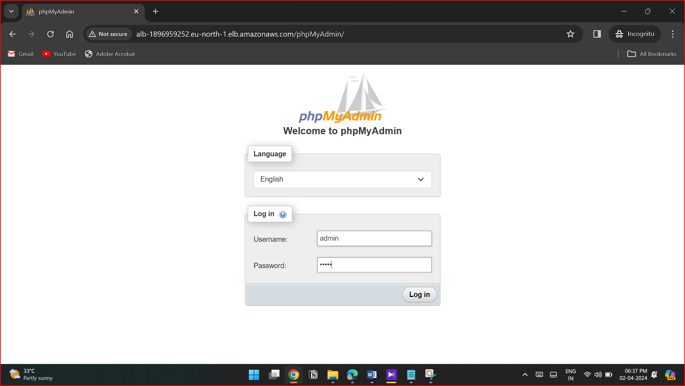

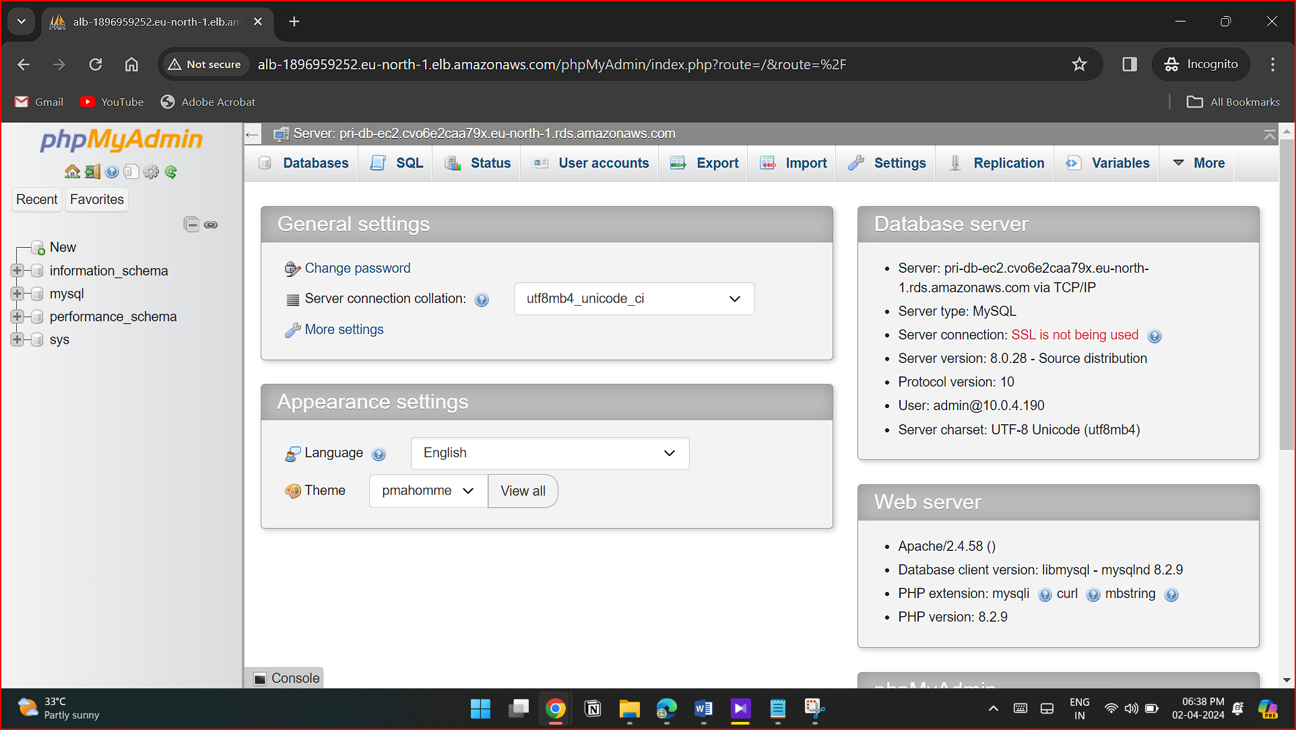

**R53**

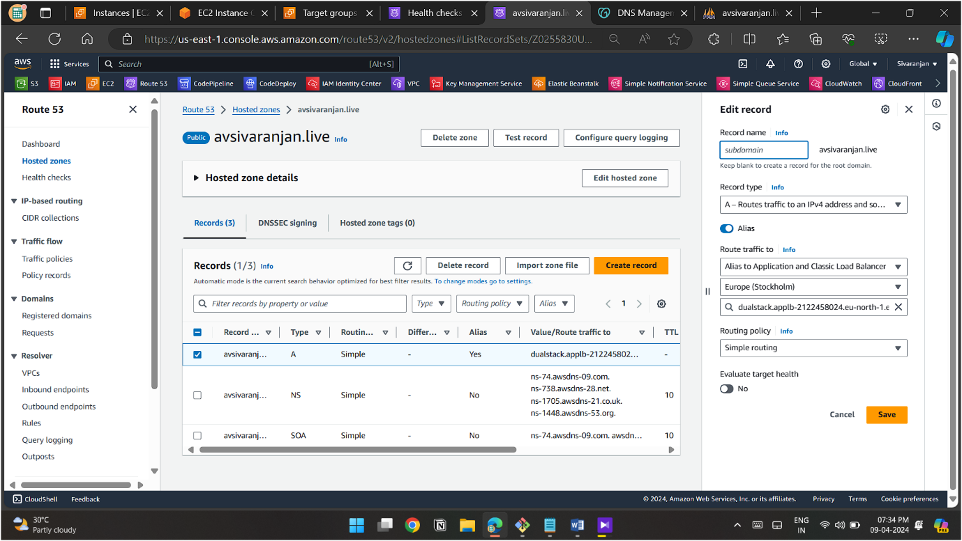

**OUTPUT**

**ALB-TG**

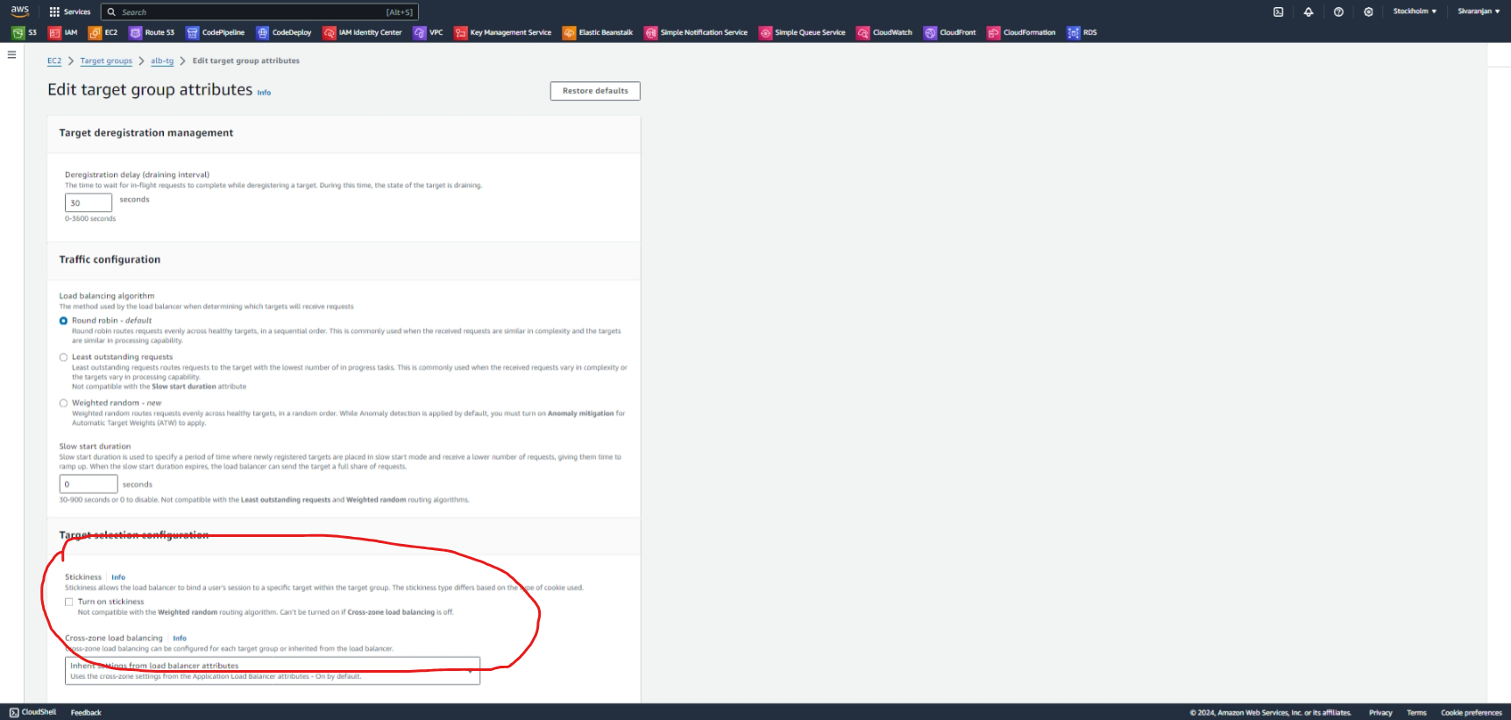

**Domain name : avsivaranjan.live**

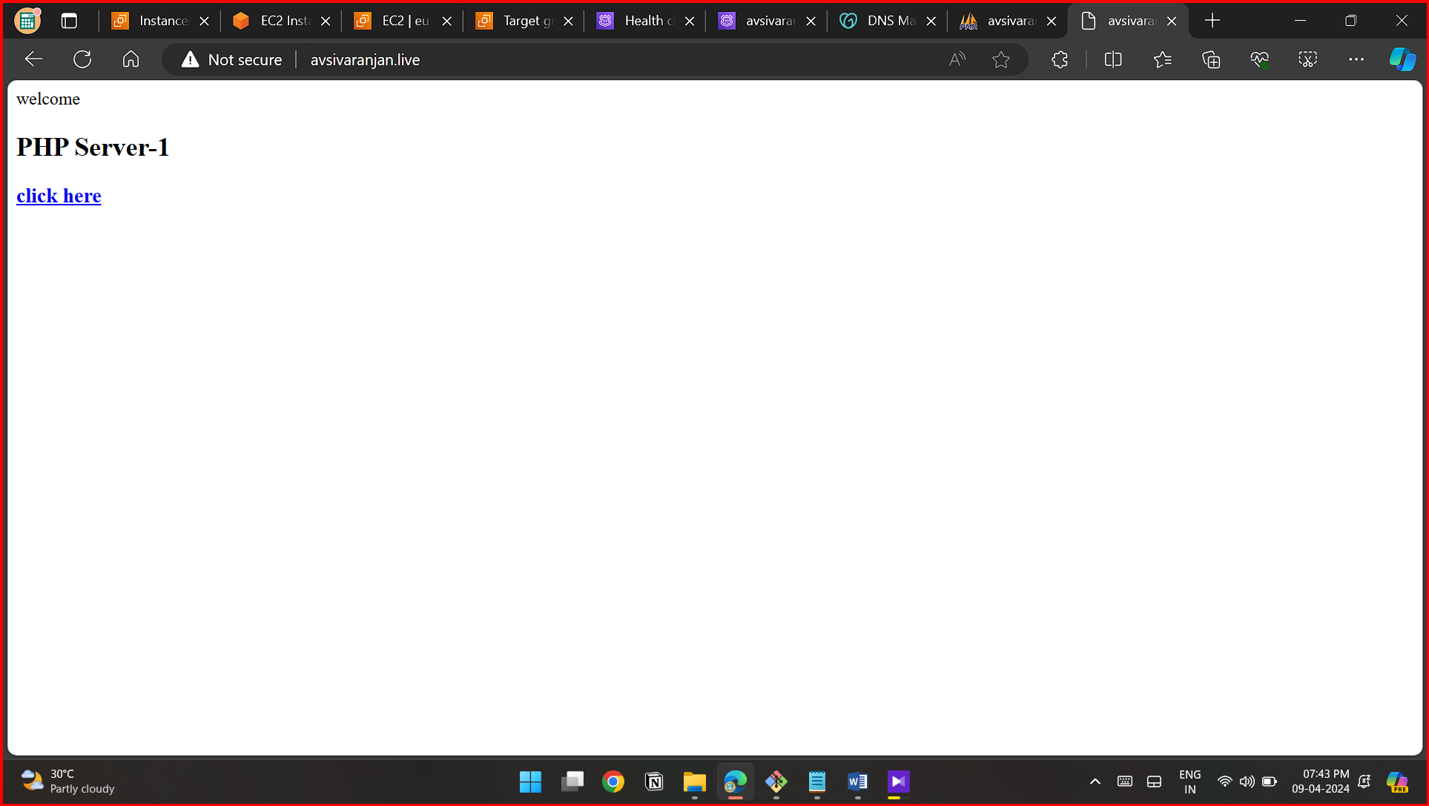

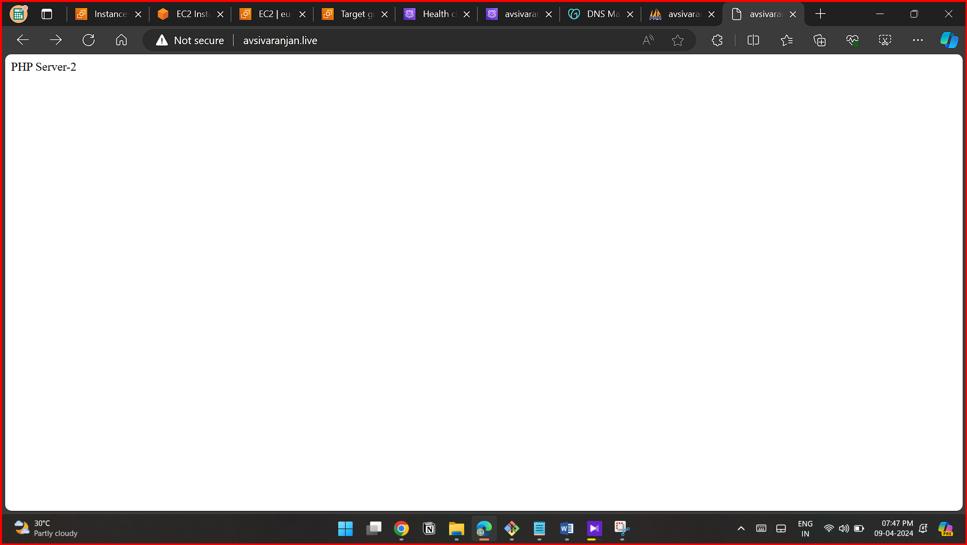

**Domain name : avsivaranjan.live/phpMyAdmin**

**ALB-TG-ATTRIBUTE->STICKYNESS**



**OUTPUT -RESULT**



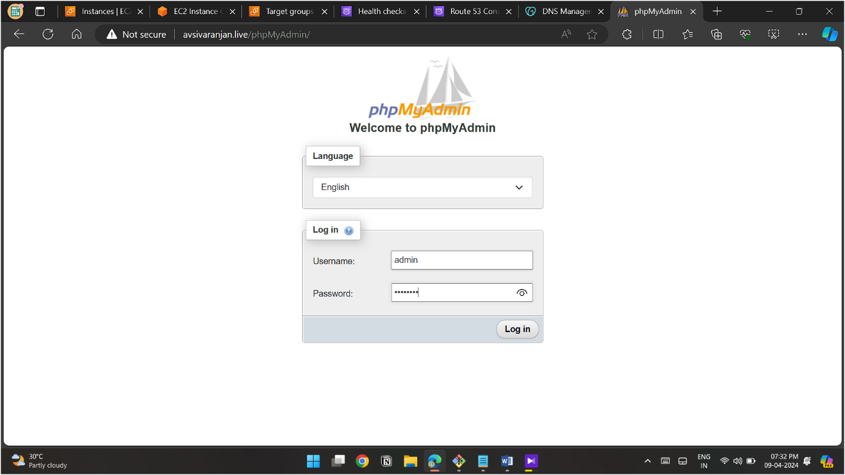



**Final Output**

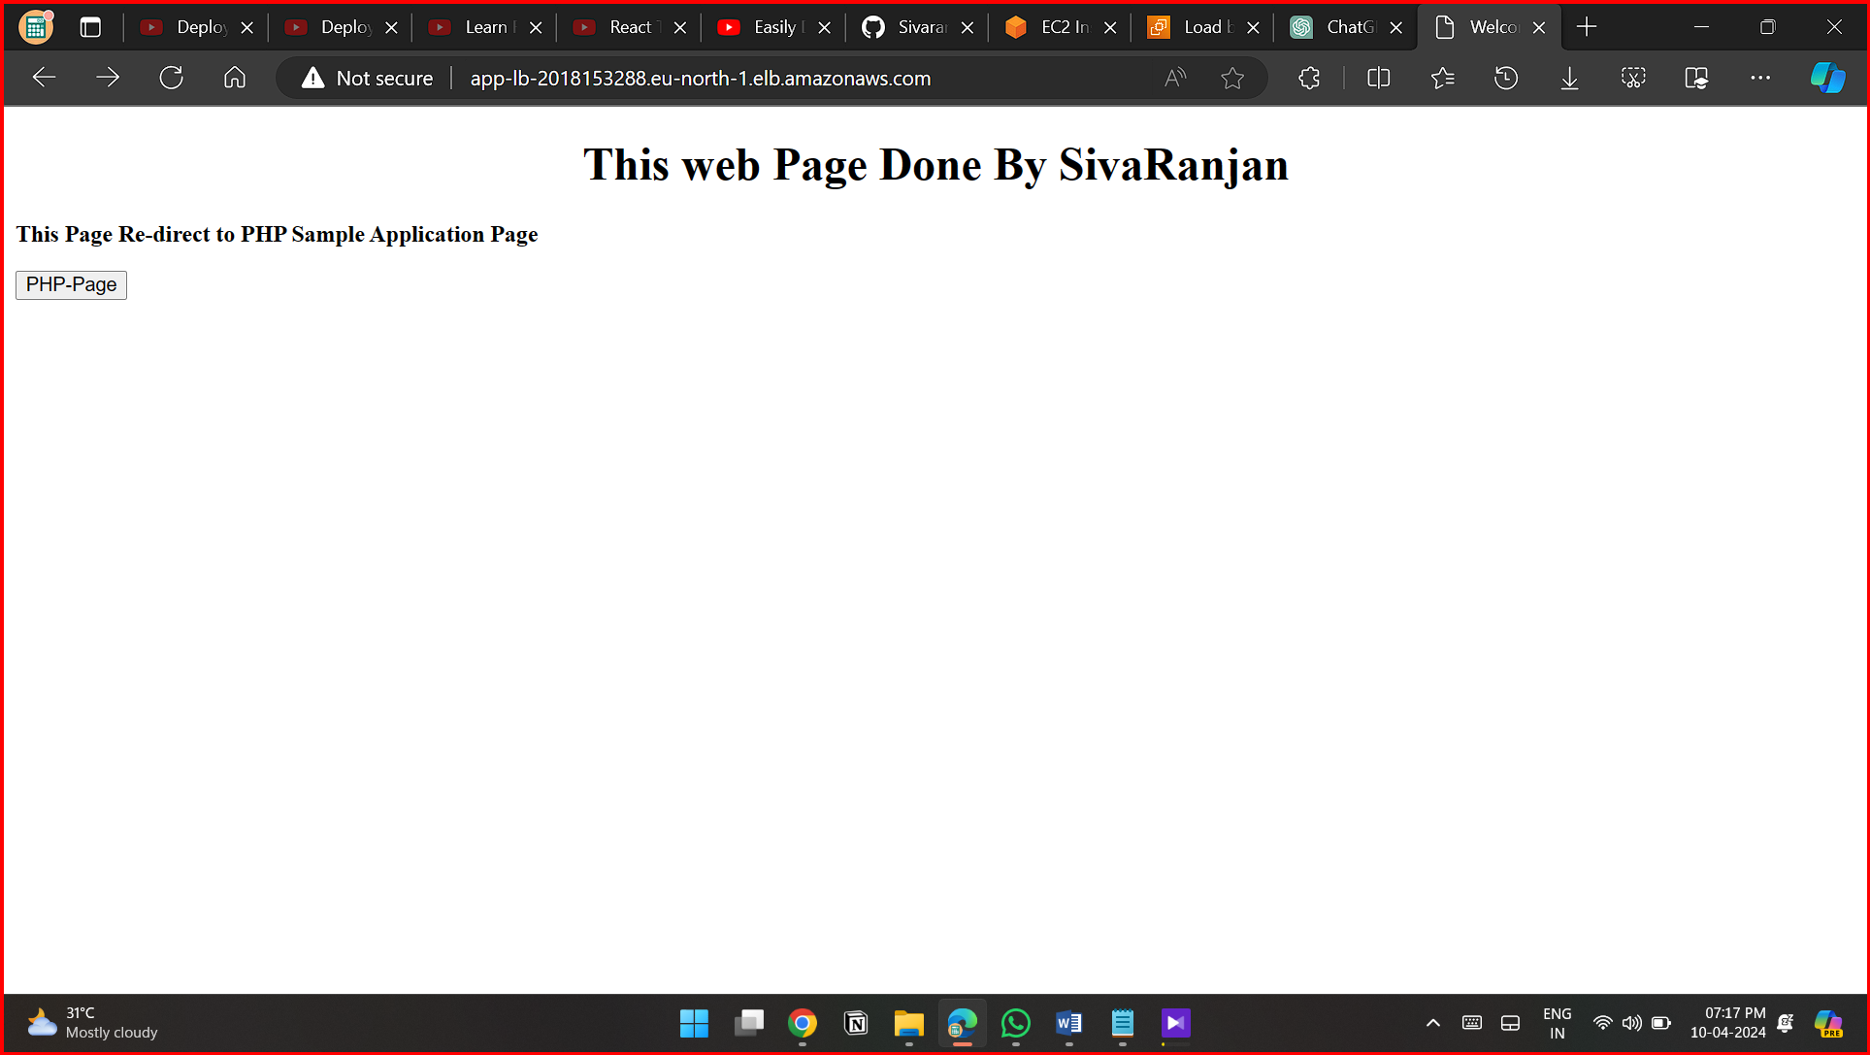

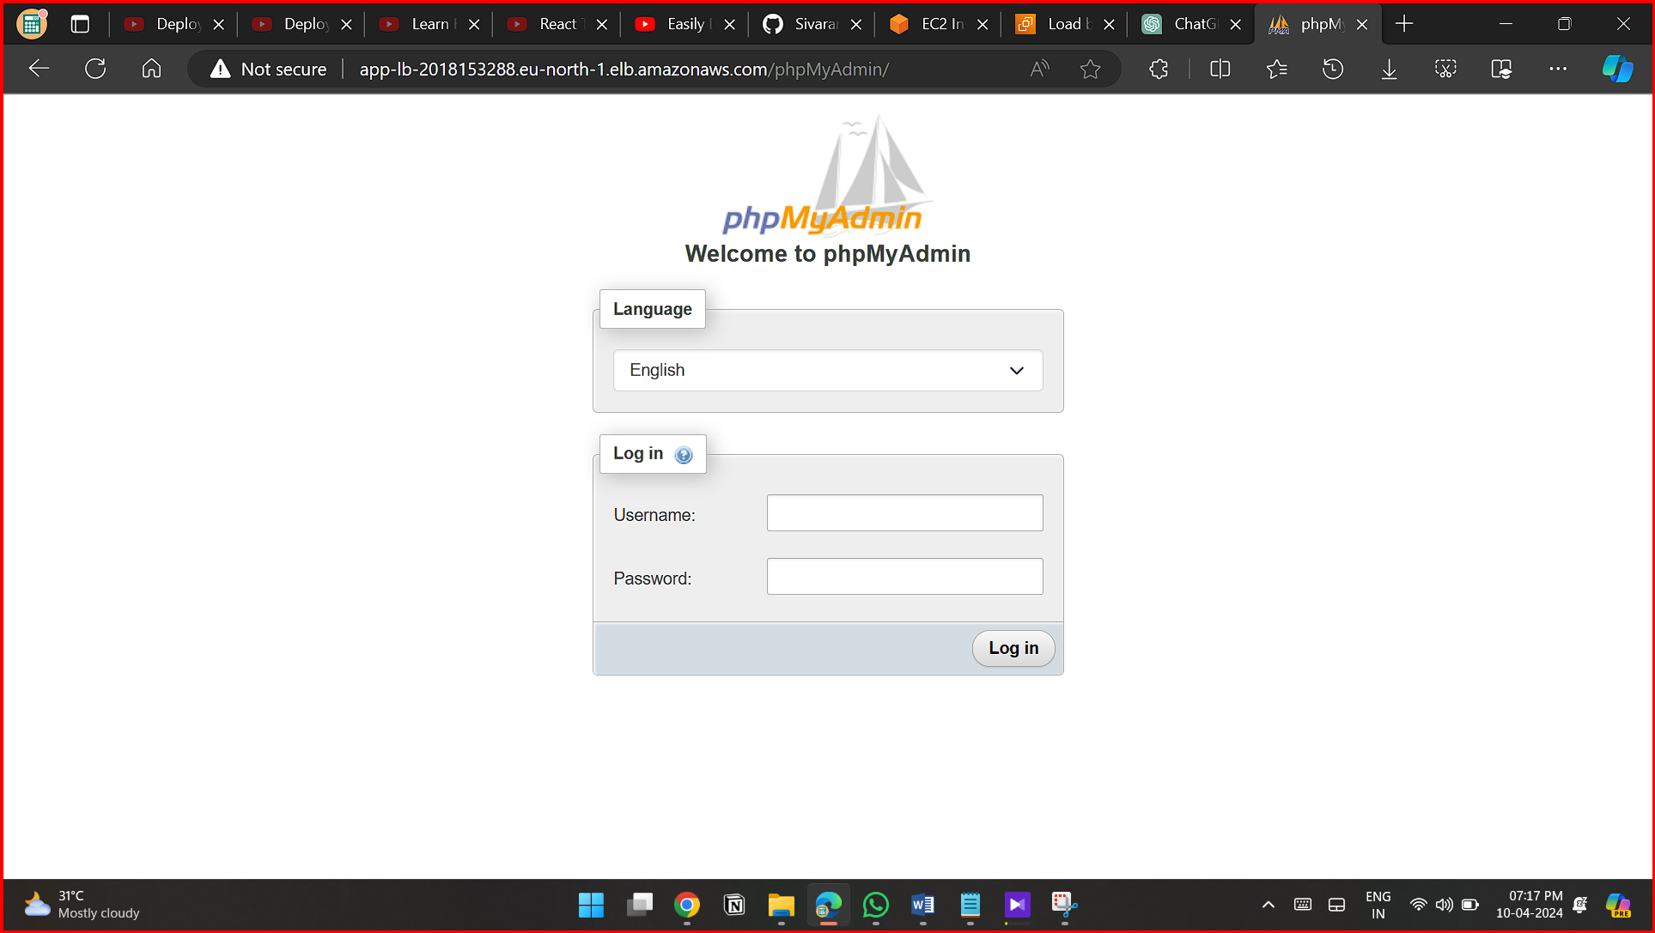

###### **To prepare the LAMP server**

1. [Connect to your instance](https://docs.aws.amazon.com/AWSEC2/latest/UserGuide/EC2_GetStarted.html#ec2-connect-to-instance-linux).
2. To ensure that all of your software packages are up to date, perform a quick software update on your instance. This process may take a few minutes, but it is important to make sure that you have the latest security updates and bug fixes.

The -y option installs the updates without asking for confirmation. If you would like to examine the updates before installing, you can omit this option.

[ec2-user ~]$ **sudo yum update -y**

1. ~~/ * Install the mariadb10.5 Amazon Linux Extras repositories to get the latest version of the MariaDB package.~~

~~[ec2-user ~]$~~ **~~sudo amazon-linux-extras install mariadb10.5~~**

~~If you receive an error stating sudo: amazon-linux-extras: command not found, then your instance was not launched with an Amazon Linux 2 AMI (perhaps you are using the Amazon Linux AMI instead). You can view your version of Amazon Linux using the following command.~~

**~~cat /etc/system-release */~~**

1. Install the php8.2 Amazon Linux Extras repositories to get the latest version of the PHP package for Amazon Linux 2.

[ec2-user ~]$ **sudo amazon-linux-extras install php8.2**

1. Now that your instance is current, you can install the Apache web server, MariaDB, and PHP software packages. Use the yum install command to install multiple software packages and all related dependencies at the same time

[ec2-user ~]$ **sudo yum install -y httpd**

You can view the current versions of these packages using the following command:

**yum info *package_name***

1. Start the Apache web server.

[ec2-user ~]$ **sudo systemctl start httpd**

1. Use the **systemctl** command to configure the Apache web server to start at each system boot.

[ec2-user ~]$ **sudo systemctl enable httpd**

You can verify that **httpd** is on by running the following command:

[ec2-user ~]$ **sudo systemctl is-enabled httpd**

###### To set file permissions

1. Add your user (in this case, ec2-user) to the apache group.

[ec2-user ~]$ **sudo usermod -a -G apache *ec2-user***

1. Log out and then log back in again to pick up the new group, and then verify your membership.
   1. Log out (use the **exit** command or close the terminal window):

[ec2-user ~]$ **exit**

* 1. To verify your membership in the apache group, reconnect to your instance, and then run the following command:
  2. [ec2-user ~]$ **groups**

ec2-user adm wheel apache systemd-journal

1. Change the group ownership of /var/www and its contents to the apache group.

[ec2-user ~]$ **sudo chown -R ec2-user:apache /var/www**

1. To add group write permissions and to set the group ID on future subdirectories, change the directory permissions of /var/www and its subdirectories.

[ec2-user ~]$ **sudo chmod 2775 /var/www && find /var/www -type d -exec sudo chmod 2775 {} \;**

1. To add group write permissions, recursively change the file permissions of /var/www and its subdirectories:

[ec2-user ~]$ **find /var/www -type f -exec sudo chmod 0664 {} \;**

Now, ec2-user (and any future members of the apache group) can add, delete, and edit files in the Apache document root, enabling you to add content, such as a static website or a PHP application.

###### To install phpMyAdmin

1. Install the required dependencies.

[ec2-user ~]$ **sudo yum install php-mbstring php-xml -y**

1. Restart Apache.

[ec2-user ~]$ **sudo systemctl restart httpd**

1. Restart php-fpm.

[ec2-user ~]$ **sudo systemctl restart php-fpm**

1. Navigate to the Apache document root at /var/www/html.

[ec2-user ~]$ **cd /var/www/html**

1. Select a source package for the latest phpMyAdmin release from <https://www.phpmyadmin.net/downloads>. To download the file directly to your instance, copy the link and paste it into a **wget** command, as in this example:

[ec2-user html]$ **wget *https://www.phpmyadmin.net/downloads/phpMyAdmin-latest-all-languages.tar.gz***

1. Create a phpMyAdmin folder and extract the package into it with the following command.

[ec2-user html]$ **mkdir phpMyAdmin && tar -xvzf *phpMyAdmin-latest-all-languages.tar.gz* -C phpMyAdmin --strip-components 1**

1. Delete the *phpMyAdmin-latest-all-languages.tar.gz* tarball.

[ec2-user html]$ **rm *phpMyAdmin-latest-all-languages.tar.gz***

**For Reference:**

**[ec2-user@ip-10-0-1-93 ~]$ history**

**1 vi key.pem**

**2 chmod 400 key.pem**

**3 ssh -i key.pem ec2-user@10.0.4.190**

**4 ssh -i key.pem ec2-user@10.0.5.230**

**5 clear**

**6 ssh -i key.pem ec2-user@10.0.4.190**

**7 ssh -i key.pem ec2-user@10.0.5.230**

**8 clear**

**9 ssh -i key.pem ec2-user@10.0.4.190**

**10 ssh -i key.pem ec2-user@10.0.5.230**

**11 ssh -i key.pem ec2-user@10.0.4.190**

**12 mysql pri-db-ec2.cvo6e2caa79x.eu-north-1.rds.amazonaws.com -u admin -p**

**13 ssh -i key.pem ec2-user@10.0.4.190**

**14 history**

**[ec2-user@ip-10-0-4-190 phpMyAdmin]$ history**

**1 vi key.pem**

**2 chmod 400 key.pem**

**3 ssh -i key.pem ec2-user@10.0.5.230**

**4 clear**

**5 exit**

**6 clear**

**7 sudo yum update -y**

**8 sudo amazon-linux-extras install php8.2**

**9 clear**

**10 sudo yum install -y httpd**

**11 yum info package_name**

**12 sudo systemctl start httpd**

**13 sudo systemctl enable httpd**

**14 sudo systemctl is-enabled httpd**

**15 clear**

**16 sudo usermod -a -G apache ec2-user**

**17 exit**

**18 clear**

**19 groups**

**20 sudo chown -R ec2-user:apache /var/www**

**21 sudo chmod 2775 /var/www && find /var/www -type d -exec sudo chmod 2775 {} \;**

**22 find /var/www -type f -exec sudo chmod 0664 {} \;**

**23 echo "<?php phpinfo(); ?>" > /var/www/html/phpinfo.php**

**24 sudo yum install php-mbstring php-xml -y**

**25 sudo systemctl restart httpd**

**26 sudo systemctl restart php-fpm**

**27 cd /var/www/html**

**28 wget https://www.phpmyadmin.net/downloads/phpMyAdmin-latest-all-languages.tar.gz**

**29 mkdir phpMyAdmin && tar -xvzf phpMyAdmin-latest-all-languages.tar.gz -C phpMyAdmin --strip-components 1**

**30 rm phpMyAdmin-latest-all-languages.tar.gz**

**31 clear**

**32 exit**

**33 cd /var/www/html**

**34 vi index.html**

**<!DOCTYPE html>**

**<html lang="en">**

**<head>**

**<meta charset="UTF-8">**

**<meta name="viewport" content="width=device-width, initial-scale=1.0">**

**<title>Welcome PHP Sample Application</title>**

**</head>**

**<body>**

**<h1><center>This web Page Done By SivaRanjan</h1>**

**<p><b>This Page Re-direct to PHP Sample Application Page</b></p>**

**<button onclick="redirectToLink()">PHP-Page</button>**

**<script>**

**function redirectToLink() {**

**// Replace 'https://example.com' with your desired link**

**window.location.href = 'http://app-lb-2018153288.eu-north-1.elb.amazonaws.com/phpMyAdmin'; //ALB DNS**

**}**

**</script>**

**</body>**

**</html> 35 exit**

**36 mysql pri-db-ec2.cvo6e2caa79x.eu-north-1.rds.amazonaws.com -u user -p**

**37 clear**

**38 cd /var/www/html**

**39 ls**

**40 cd phpMyAdmin/**

**41 ls**

**42 mv config.sample.inc.php config.inc.php**

**43 vi config.inc.php**

**/* Server parameters */**

**$cfg['Servers'][$i]['host'] = 'pri-db-ec2.cvo6e2caa79x.eu-north-1.rds.amazonaws.com'; //db-endpoint**

**44 clear**

**45 exit**

**46 vi config.inc.php**

**47 ls**

**48 cd /var/www/html**

**49 ls**

**50 cd phpMyAdmin/**

**51 ls**

**52 vi config.inc.php**

**53 clear**

**54 history**

**[ec2-user@ip-10-0-5-230 ~]$ history**

**1 clear**

**2 exit**

**3 clear**

**4 sudo yum update -y**

**5 sudo amazon-linux-extras install php8.2**

**6 sudo yum install -y httpd**

**7 sudo systemctl start httpd**

**8 sudo systemctl enable httpd**

**9 sudo systemctl is-enabled httpd**

**10 sudo usermod -a -G apache ec2-user**

**11 exit**

**12 groups**

**13 sudo chown -R ec2-user:apache /var/www**

**14 sudo chmod 2775 /var/www && find /var/www -type d -exec sudo chmod 2775 {} \;**

**15 find /var/www -type f -exec sudo chmod 0664 {} \;**

**16 sudo yum install php-mbstring php-xml -y**

**17 sudo systemctl restart httpd**

**18 sudo systemctl restart php-fpm**

**19 cd /var/www/html**

**20 wget https://www.phpmyadmin.net/downloads/phpMyAdmin-latest-all-languages.tar.gz**

**21 mkdir phpMyAdmin && tar -xvzf phpMyAdmin-latest-all-languages.tar.gz -C phpMyAdmin --strip-components 1**

**22 rm phpMyAdmin-latest-all-languages.tar.gz**

**23 exit**

**24 cd /var/www/html**

**25 echo "PHP-Server 2" > index.html**

**26 exit**

**27 history**

**[ec2-user@ip-10-0-5-230 ~]$**